# Instructions – Exercise 6.3 - Layouts

**Layout**

base-layout

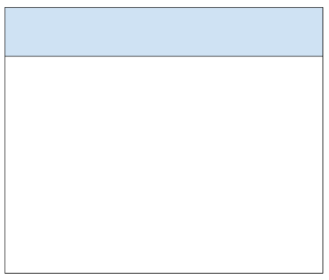

gpa-calculator-app, part 1

**Instructions**

* Generate a new Angular application and name it gpa-calculator-app1
  + Accept “Y” for routing
* Install the following npm packages:
  + Angular material
    - ng add @angular/material
    - Select the “Deep Purple/Amber theme
    - Yes to Angular Material typography styles
    - Yes to browser animations
  + Flex-layout
    - npm install @angular/flex-layout
* Generate the following components: auth-layout, base-layout, not-found, and home
  + ng g c auth-layout
  + ng g c base-layout
  + ng g c not-found
  + ng g c home
* app.component.html
  + Replace the prebuilt HTML code with a single <router-outlet> element
* app.module.ts
  + Import MatToolbarModule, FlexLayoutModule, MatCardModule, and MatButtonModule
    - import { MatToolbarModule } from ‘@angular/material/toolbar’;
    - import { FlexLayoutModule } from ‘@angular/flex-layout’;
    - import { MatCardModule } from ‘@angular/material/card’;
    - import { MatButtonModule } from ‘@angular/material/button’;
  + Add the imported components to the imports array
* base-layout.component.html
  + Replace the prebuilt HTML with an Angular toolbar, main div container and another router-outlet
  + <mat-toolbar>
    - Main logo
    - Home link
      * <button mat-button routerLink=”/”>Home</button>
  + Main container
    - Flex layout row with a mat-card, mat-card-title, and mat-card-content
      * mat-card-title
        + Display the variable “assignment” value
      * mat-card-content
        + router-outlet
  + Note: you are essentially rebuilding the layout we used in in-n-out-books app.component.html file
* base-layout.component.ts
  + Create a string variable named assignment
  + In the components constructor assign the assignment variable a value of ‘Exercise 6.3 - Layouts’
* auth-layout.component.ts
  + Replace the prebuilt HTML code with a single router-outlet
* app-routing.module.ts
  + Add a parent path for the BaseLayoutComponet and one child path for the HomeComponent
    - path: ‘’
    - component: BaseLayoutComponent
    - children: [ {path: ‘’, component: HomeComponent } ]
  + Add a parent path for AuthLayoutComponent and one child path for the NotFoundComponent
    - path: ‘session’,
    - component: AuthLayoutComponent
    - children: [ {path: ‘not-found’, component: NotFoundComponent }]
  + Add another path for “catching all invalid URL requests”
    - path: ‘**’
    - redirectTo: ‘session/not-found’
* not-found.component.html
  + Design your own custom 404 page.  For inspiration, search the internet for 404-page examples.
  + Note: Points will be deducted if the 404 page is not customized and/or only contains a single header element with the word 404
* Run and test the application
  + Verify the navbar is appearing at the top of the website
  + Verify the assignment number is appearing
  + Enter an invalid URL (<http://localhost:4200/asdf> and verify the NotFound component appears with the custom styling you created